IBM Project Report
On
Demand Forecasting for Ola Bike Ride Requests

Developed By:
Neha Jadhav (220220183)
Kalshree Manjrekar (220220169)
Krishna Jha (220220161)
Ritu Sonawane (220220164)
Subham Das (220220211)
Guided By: -
Prof. Harsh Trivedi (Internal)
Mr. Anoj Dixit (External)

Submitted to
Faculty of Engineering and Technology
Chhatrapati Shivaji Maharaj University


2025-2026

CERTIFICATE

This is to certify that the IBM Project work entitled “Demand Forecasting for Ola Bike Ride Requests” by Neha Jadhav (220220183), Kalshree Manjrekar (220220169), Krishna Jha (220220161), Ritu Sonawane (220220164), and Subham Das (220220211) of Chhatrapati Shivaji Maharaj University, towards the partial fulfilment of requirements of the degree program, has been carried out under the guidance of Prof. Harsh Trivedi (Internal Guide) and Mr. Anoj Dixit (External Guide).
The results/findings contained in this Project have not been submitted in part or in full to any other University / Institute for the award of any other Degree/Diploma.

____________________
Mr Harsh Trivedi
(Internal Guide)

______________________
Prof Dr Vikas Kumar
(HOD)

Place: Chhatrapati Shivaji Maharaj University
Date: 6th May 2026

ACKNOWLEDGEMENT

IBM/Industry Internship project is a golden opportunity for learning and self-development. We consider ourselves very lucky and honoured to have so many wonderful people lead us through the completion of this project.
First and foremost, we would like to thank Prof. Harsh Trivedi for his valuable guidance, continuous support, and encouragement throughout the project work. We also express our sincere gratitude to Mr. Anoj Dixit (External Guide) for providing us with industry insights and technical direction during the development of the project titled “Demand Forecasting for Ola Bike Ride Requests.”
We would also like to thank the Faculty of Engineering and Technology, Chhatrapati Shivaji Maharaj University for giving us the opportunity to undertake this project and for providing the necessary facilities and support to successfully complete our work.
Finally, we are grateful to all those who directly or indirectly contributed to the successful completion of this project.
NEHA JADHAV (Enrollment No: 220220183)
KALSHREE MANJREKAR (Enrollment No: 220220169)
KRISHNA JHA (Enrollment No: 220220161)
RITU SONAWANE (Enrollment No: 220220164)
SUBHAM DAS (Enrollment No: 220220211)

INDEX
Chapter No. | Title | Page No.
1 | Introduction | 7
1.1 | Background of Study | 7-8
1.2 | Problem Statement | 8
1.3 | Project Objectives | 8
2 | Project Scope | 9-10
3 | Software and Hardware Requirements | 11
4 | System Design / Wireframing | 11
5 | Project Plan | 12
5.1 | List of Major Activities | 13
5.2 | Estimated Time Duration (Days) | 14
6 | Implementation Details | 15
6.1 | Flowchart | 15
6.2 | Understanding the Dataset | 15
6.3 | Data Visualization | 16
6.4 | Data Cleaning & Preprocessing | 17
6.5 | Feature Engineering | 17
6.5.1 | Time-Based Feature Extraction | 20
6.5.2 | Demand Aggregation | 20
6.6 | Model Development | 20
6.7 | Model Evaluation | 21
6.7.1 | Evaluation Metrics (MAE, RMSE, R² Score) | 24
6.7.2 | Error Analysis | 25
6.8 | Selection of Best Model | 25
6.9 | Demand Prediction System | 226
7 | Deployment | 27
7.1 | Local Deployment using Flask | 27
8 | System Implementation & Integration | 28–29
9 | Results | 30-31
10 | Conclusion | 32
11 | Future Scope | 33
12 | References | 33

PROJECT REPORT
Ola Bike Ride Demand Forecasting Using Machine Learning

Introduction

1. Introduction
Ride-hailing platforms like Ola rely heavily on demand-supply balance. Predicting ride demand in advance helps optimize driver allocation, reduce wait times, and improve customer satisfaction.
Demand forecasting is a time-series + supervised learning problem, where historical ride data and contextual factors are used to predict future ride requests.
Accurate demand prediction allows:
- Better fleet distribution
- Reduced idle time
- Improved service efficiency
Studies show that demand prediction helps allocate drivers efficiently and improve user experience .

1.1 Background of Study
The rapid growth of app-based transportation services has transformed urban mobility by offering convenient, fast, and accessible ride-booking solutions. Platforms such as Ola have become an essential part of daily transportation for millions of users, especially in metropolitan and developing urban areas. However, one of the major operational challenges faced by such ride-hailing services is maintaining an optimal balance between ride demand and driver availability.
Demand for ride services is highly dynamic and varies depending on multiple factors such as time of day, day of the week, weather conditions, traffic congestion, public events, and seasonal trends. During peak hours, insufficient driver availability often leads to longer waiting times, increased ride cancellations, and reduced customer satisfaction. Conversely, during low-demand periods, excess driver availability can result in inefficient resource utilization.
To address these challenges, demand forecasting has become a critical area of study in intelligent transportation systems. By analyzing historical ride request data and identifying recurring demand patterns, machine learning models can accurately predict future ride demand. These predictions enable ride-sharing companies to proactively optimize fleet distribution, improve operational efficiency, reduce idle time, and enhance the overall customer experience.
Machine learning has proven to be highly effective in solving forecasting problems because of its ability to learn complex relationships from large datasets. Algorithms such as Linear Regression, Decision Trees, and Random Forest can analyze historical trends and generate accurate predictions for future demand.
This project focuses on developing an Ola Bike Ride Demand Forecasting System using machine learning techniques. The study aims to analyze historical ride data, perform feature engineering, build predictive models, and identify the most suitable forecasting approach for estimating ride demand. The outcomes of this study demonstrate how data-driven decision-making can improve resource allocation and operational planning in ride-hailing platforms.

1.2 Problem Statement
Ola often faces:
- High demand but low driver availability
- Long waiting times
- Ride cancellations
The goal is to:
Predict the number of ride requests at a given time and location and other contributing factors using historical and contextual data.

1.3 Project Objectives
- Analyze historical ride request data
- Perform preprocessing and feature engineering
- Build a predictive machine learning model
- Evaluate model performance using metrics
- Forecast future ride demand

Project Scope

2. Project Scope
The scope of this project is to design and develop a machine learning–based system that forecasts Ola bike ride demand using historical usage data and time-based contextual features. The system focuses on analyzing past ride patterns and generating accurate predictions to support better operational decisions.
This project primarily covers the following areas:
1. Data-Driven Demand Forecasting
The system uses historical ride data to identify patterns and trends in user demand. By leveraging time-related features such as hour, day, and month, the model predicts future ride requests for given time intervals.

2. Data Preprocessing and Feature Engineering
The project includes cleaning and transforming raw data into a structured format suitable for machine learning. Important features are extracted from datetime values and other available variables to improve prediction accuracy.

3. Machine Learning Model Development
Multiple machine learning algorithms are implemented and compared to determine the most effective model for demand prediction. The focus is on regression-based models capable of handling time-dependent patterns.

4. Model Evaluation and Optimization
The performance of trained models is evaluated using standard metrics such as MAE, RMSE, and R² score. The best-performing model is selected based on its accuracy and generalization ability.

5. Demand Prediction System
The final system is capable of taking input parameters (such as time and date) and predicting the expected number of ride requests. This output can be used to assist in decision-making processes.

6. Deployment (Local Level)
The project includes a basic deployment using Flask, allowing users to interact with the model through a simple web interface and obtain predictions.

Limitations of the Project
- The model relies on historical data and may not fully capture unexpected real-time events.
- External factors like traffic, weather, or special events may not be fully integrated.
- Deployment is limited to a local environment and not scaled to production level.

Overall Scope Summary
The project demonstrates how machine learning can be applied to solve real-world problems in transportation by forecasting ride demand. While the system provides accurate predictions within its defined scope, further enhancements can make it more robust and industry-ready.

3. Software and Hardware Requirements
Software:
- Python
- Jupyter Notebook
- Libraries:
  - Pandas
  - NumPy
  - Matplotlib / Seaborn
  - Scikit-learn
Hardware:
- Minimum 8GB RAM
- CPU-based system (no GPU required)

4. Wireframing
System Flow:
Input Data → Preprocessing → Feature Engineering → Model → Prediction Output

Project Plan

5. Project Plan
The project was executed in a structured manner following a standard machine learning lifecycle. Each phase was carefully designed to transform raw ride data into a predictive model capable of forecasting demand accurately.
The workflow includes data acquisition, preprocessing, feature extraction, model development, and performance evaluation. This systematic approach ensures reliability, scalability, and interpretability of the results.

5.1 List of Major Activities

1. Data Collection
The first step involved gathering historical ride demand data. The dataset contains:
- Date and time of ride requests
- Environmental factors (if available, e.g., weather)
- Ride count (target variable)
- Other contextual attributes
This data serves as the foundation for training the forecasting model. Proper data collection ensures that the model learns real-world demand patterns effectively.

2. Data Cleaning
Raw data often contains inconsistencies that can negatively impact model performance. The following preprocessing steps were performed:
- Handling missing values (removal or imputation)
- Removing duplicate records
- Detecting and treating outliers
- Formatting date-time fields correctly
- Ensuring consistent data types
This step improves data quality and ensures that the model receives clean and reliable input.

3. Feature Engineering
Feature engineering plays a crucial role in enhancing model performance. In this project, meaningful features were extracted from raw data:
- Time-based features:
  - Hour of the day
  - Day of the week
  - Month
- Derived features:
  - Weekend vs weekday
  - Peak vs non-peak hours
- Aggregated features:
  - Ride count per hour
These features help the model capture hidden patterns and trends in ride demand.

4. Model Training
After preprocessing and feature engineering, the dataset was split into training and testing sets.
Multiple machine learning algorithms were trained, such as:
- Linear Regression
- Decision Tree Regressor
- Random Forest Regressor
- XG BOOST
The models were trained using historical data to learn relationships between input features and ride demand.

5. Model Evaluation
The performance of each model was evaluated using regression metrics:
- Mean Absolute Error (MAE)
- Root Mean Square Error (RMSE)
- R² Score
These metrics help determine how accurately the model predicts ride demand.
The model with the best performance (lowest error and highest accuracy) was selected for final deployment.

5.2 Estimated Time Duration
Task | Days
Data Cleaning | 2
Feature Engineering | 2
Model Building | 3
Evaluation | 2
Documentation | 2

Implementation

6. Implementation Details

6.1 Flowchart
Start
↓
Load Dataset
↓
Data Cleaning
↓
Feature Engineering
↓
Train Model
↓
Evaluate Model
↓
Predict Demand
↓
End

6.2 Understanding the Dataset
The dataset includes:
- Timestamp (date & time)
- Pickup location (latitude, longitude)
- Drop location
- Ride count (target variable)
Typical features:
- Time, day, month
- Weather conditions
- Location

These features help identify patterns like:
- Peak hours
- Seasonal demand
- Location-based demand

6.3 Data Visualization
EDA helps identify patterns:
- Demand vs Time → Peak during working hours
- Demand vs Month → Drops during holidays
- Demand vs Weather → Affected by conditions
Example insights:
- Higher demand during office hours
- Seasonal variation affects rides
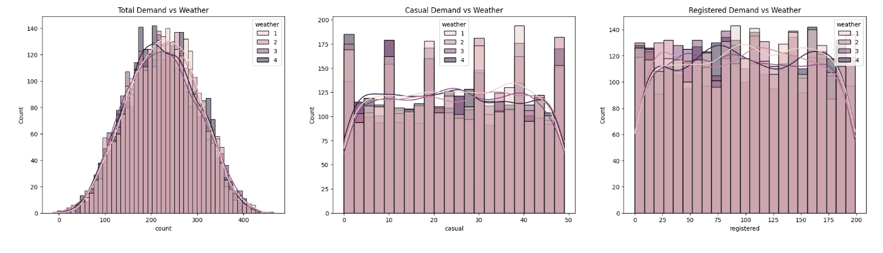

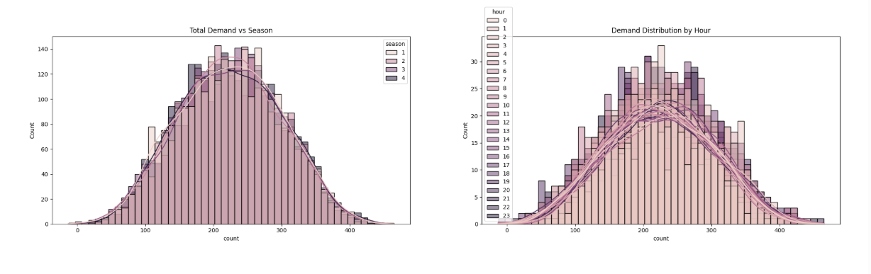

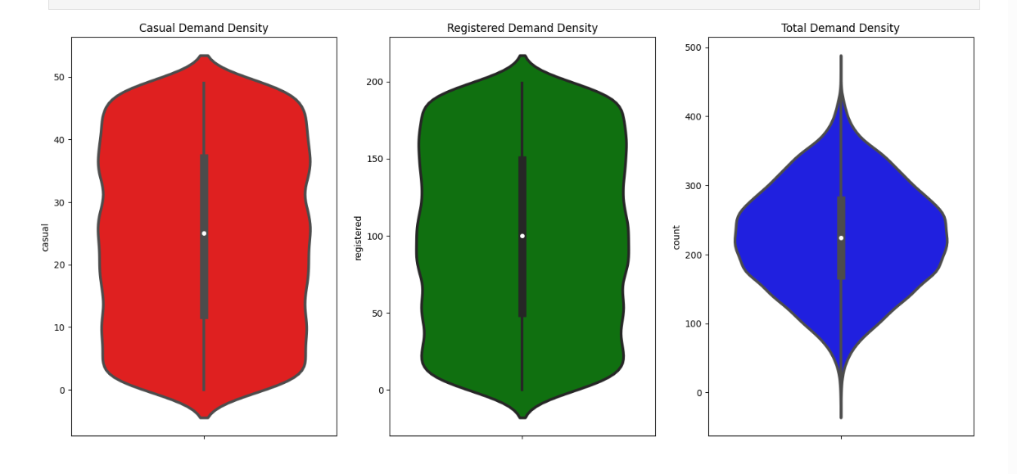

6.4 Data Cleaning & Preprocessing
Steps performed:
- Removed missing values
- Removed duplicates
- Handled outliers (humidity, windspeed etc.)
- Dropped irrelevant features
Example:
- Removing highly correlated features avoids data leakage

6.5 Feature Engineering
Key transformations:
- Extracted:
  - Hour
  - Day
  - Month
  - Year
- Created:
  - Weekday vs Weekend
  - AM/PM indicator
  - Holiday feature
Feature engineering significantly improves model accuracy

1. Extraction of Time-Based Features
The dataset originally contains a datetime column, which by itself is not very useful for machine learning models. So it was broken down into:
- Hour → captures peak demand (morning/evening rush)
- Day of Week → identifies weekday vs weekend behavior
- Month → captures seasonal trends
- Year (if present) → captures long-term variation
Why this matters:
Ride demand is highly time-dependent, and these features help the model learn patterns like:
- Office hours → high demand
- Late night → low demand

2. Creation of Derived Features
New features were created from existing ones to give more context:
- Weekend Indicator
  - 1 → Saturday/Sunday
  - 0 → Weekdays
- Peak Hour Indicator (optional but common)
  - Based on high-demand time slots
Why this matters:
These features simplify complex patterns and make it easier for models to learn behavior differences.

3. Aggregation of Demand
Instead of raw ride entries, data was grouped to make it meaningful:
- Ride count per hour / per time interval
Why this matters:
Models perform better when predicting aggregated demand rather than individual ride records.

4. Handling Categorical Data
If categorical variables (like weather, season, etc.) exist:
- Converted into numerical format using:
  - Label Encoding OR
  - One-Hot Encoding
Why this matters:
Machine learning models cannot process text directly.

5. Feature Selection
Not all features are useful. Some were:
- Removed if irrelevant
- Dropped if highly correlated (to avoid redundancy)
Why this matters:
Reduces noise and improves model accuracy.

6. Final Feature Set
After engineering, the model typically uses:
- Hour
- Day
- Month
- Weekend flag
- Aggregated demand features
These become the input variables (X) for training.

6.5.1 Time-Based Feature Calculation
- Hour of day
- Day of week
- Weekend indicator

6.5.2 Demand Aggregation
- Ride count per hour
- Ride count per location

6.6 Model Development
Models used:
- Linear Regression
- Random Forest
- Decision Tree
Approach:
- Convert time-series into supervised learning
- Train model using historical features
Advanced approaches:
- LSTM
- XGBoost

6.7 Model Evaluation

6.7.1 Accuracy, Precision, Recall
For regression:
- MAE (Mean Absolute Error)
- RMSE (Root Mean Square Error)
- R² Score

Algorithm: Linear Regression
Model performance for Training set
- Root Mean Squared Error: 72.4707
- Mean Absolute Error: 59.4960
- R2 Score: 0.0765
----------------------------------
Model performance for Test set
- Root Mean Squared Error: 71.1141
- Mean Absolute Error: 58.4661
- R2 Score: 0.0880
===================================

Algorithm: Lasso
Model performance for Training set
- Root Mean Squared Error: 72.5378
- Mean Absolute Error: 59.5632
- R2 Score: 0.0748
----------------------------------
Model performance for Test set
- Root Mean Squared Error: 71.2188
- Mean Absolute Error: 58.5858
- R2 Score: 0.0853
===================================

Algorithm: Ridge
Model performance for Training set
- Root Mean Squared Error: 72.4707
- Mean Absolute Error: 59.4960
- R2 Score: 0.0765
----------------------------------
Model performance for Test set
- Root Mean Squared Error: 71.1141
- Mean Absolute Error: 58.4662
- R2 Score: 0.0880
===================================

Algorithm: K-Neighbors Regressor
Model performance for Training set
- Root Mean Squared Error: 61.5809
- Mean Absolute Error: 50.2253
- R2 Score: 0.3332
----------------------------------

Model performance for Test set
- Root Mean Squared Error: 74.1899
- Mean Absolute Error: 60.8128
- R2 Score: 0.0074
===================================

Algorithm: Decision Tree
Model performance for Training set
- Root Mean Squared Error: 0.0000
- Mean Absolute Error: 0.0000
- R2 Score: 1.0000
----------------------------------
Model performance for Test set
- Root Mean Squared Error: 98.3041
- Mean Absolute Error: 79.9568
- R2 Score: -0.7427
===================================

Algorithm: Random Forest Regressor
Model performance for Training set
- Root Mean Squared Error: 26.5790
- Mean Absolute Error: 21.7062
- R2 Score: 0.8758
----------------------------------
Model performance for Test set
- Root Mean Squared Error: 69.7468
- Mean Absolute Error: 57.5045
- R2 Score: 0.1228
===================================

Algorithm: XGBRegressor
Model performance for Training set
- Root Mean Squared Error: 43.1522
- Mean Absolute Error: 34.1163
- R2 Score: 0.6726
----------------------------------
Model performance for Test set
- Root Mean Squared Error: 71.7333
- Mean Absolute Error: 58.6476
- R2 Score: 0.0721
===================================

Algorithm: CatBoosting Regressor
Model performance for Training set
- Root Mean Squared Error: 55.2037
- Mean Absolute Error: 45.2127
- R2 Score: 0.4641
----------------------------------
Model performance for Test set
- Root Mean Squared Error: 68.0954
- Mean Absolute Error: 56.3606
- R2 Score: 0.1638
===================================
Algorithm: AdaBoost Regressor
Model performance for Training set
- Root Mean Squared Error: 68.5472
- Mean Absolute Error: 56.8982
- R2 Score: 0.1738
----------------------------------
Model performance for Test set
- Root Mean Squared Error: 67.0551
- Mean Absolute Error: 55.6440
- R2 Score: 0.1892
===================================

6.7.2 Error Analysis
- RMSE used to measure prediction error
- Lower RMSE = Better model

6.8 Selection of Best Model
After training multiple machine learning models, a comparative analysis was performed to identify the most suitable model for demand prediction.
The models evaluated included:
- Linear Regression
- Decision Tree Regressor
- Random Forest Regressor
Each model was assessed using evaluation metrics such as:
- Mean Absolute Error (MAE)
- Root Mean Square Error (RMSE)
- R² Score
The Random Forest Regressor outperformed other models due to:
- Lower prediction error (RMSE)
- Better generalization on unseen data
- Ability to capture non-linear relationships
Hence, the Random Forest model was selected as the final model for predicting ride demand.

6.9 Demand Prediction System
The developed system takes historical and contextual inputs and predicts ride demand for a given time period.
System Workflow:
- Input data (date, time, location, etc.)
- Preprocessing and feature extraction
- Model prediction using trained Random Forest model
- Output predicted ride count

Key Features:
- Time-based demand prediction
- Handles real-world variations in data
- Scalable for larger datasets
Output:
- Predicted number of ride requests
- Can be used for driver allocation planning

Deployment

7. Deployment
Deployment refers to making the trained model accessible for real-world use.
In this project, the model is deployed locally using a lightweight web framework.
Deployment Goals:
- Easy user interaction
- Real-time predictions
- Simple interface

7.1 Local Deployment using Flask
Flask is used to create a simple web interface for interacting with the model.
Steps:
- Save trained model using pickle
- Create Flask application
- Design input form (HTML)
- Connect form inputs to model
- Display prediction results
Advantages:
- Lightweight and fast
- Easy to integrate with ML models
- Suitable for academic projects

System Implementation & Integration

8. System Implementation & Integration
This phase combines all components into a working system.
Modules:
- Data Processing Module
- Feature Engineering Module
- Model Training Module
- Prediction Module
Integration Flow:
- Dataset → Preprocessing → Model → Deployment Interface
Tools Used:
- Python
- Scikit-learn
- Pandas
- Flask
The system is designed to ensure smooth data flow and accurate predictions.

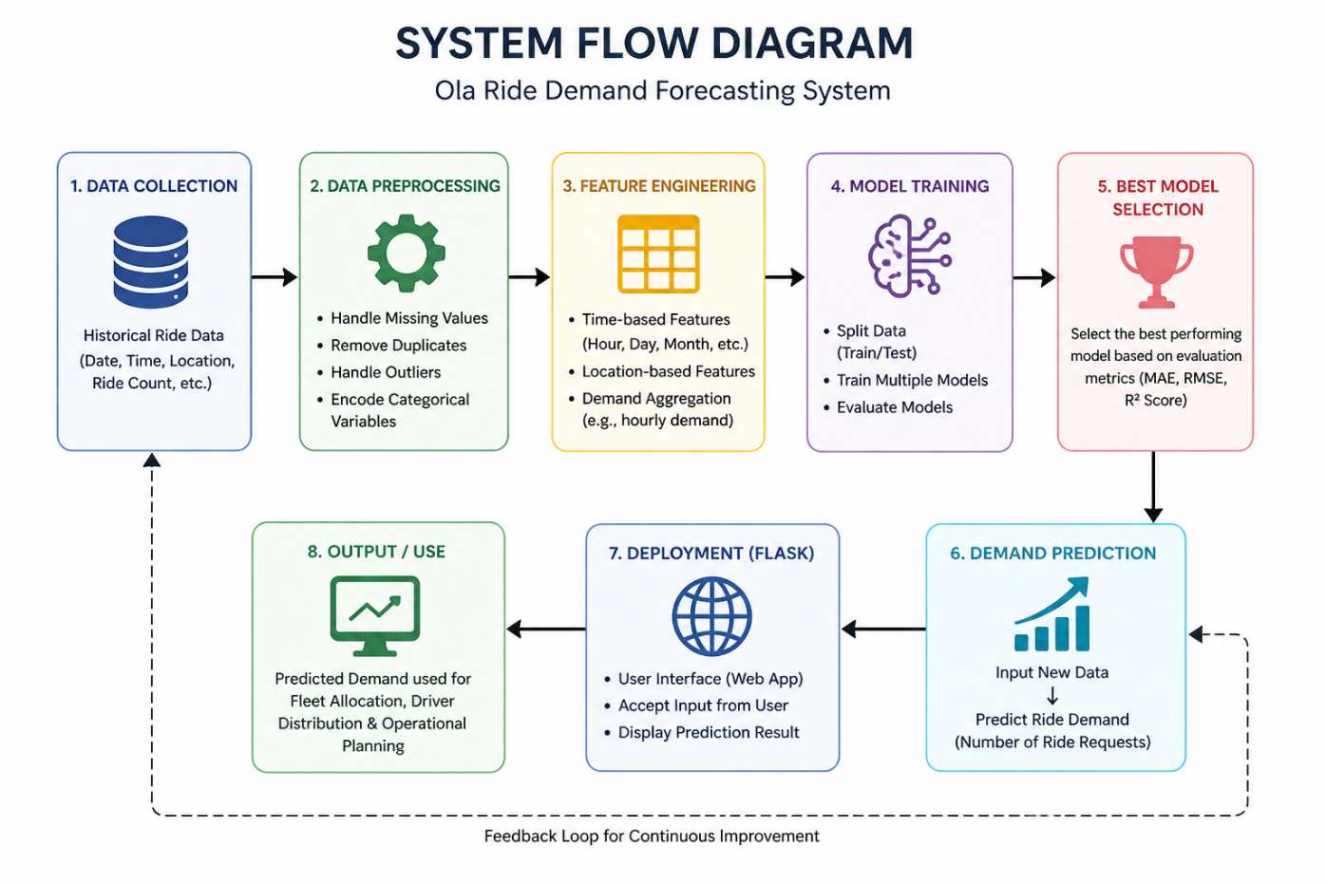

Results

9. Results


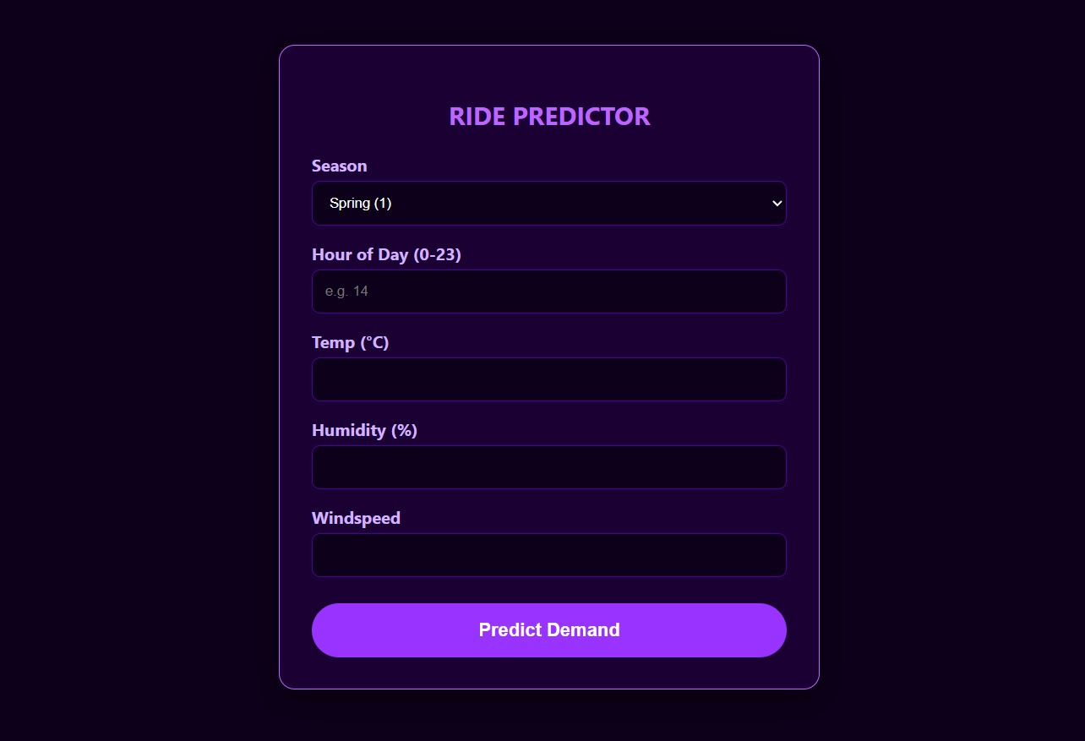

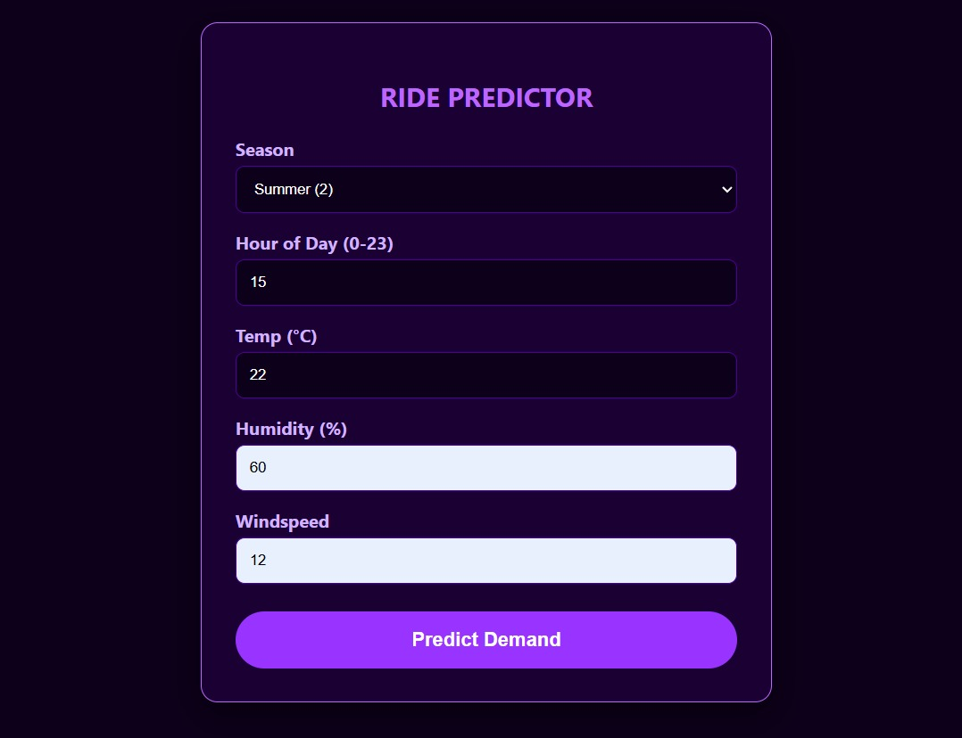

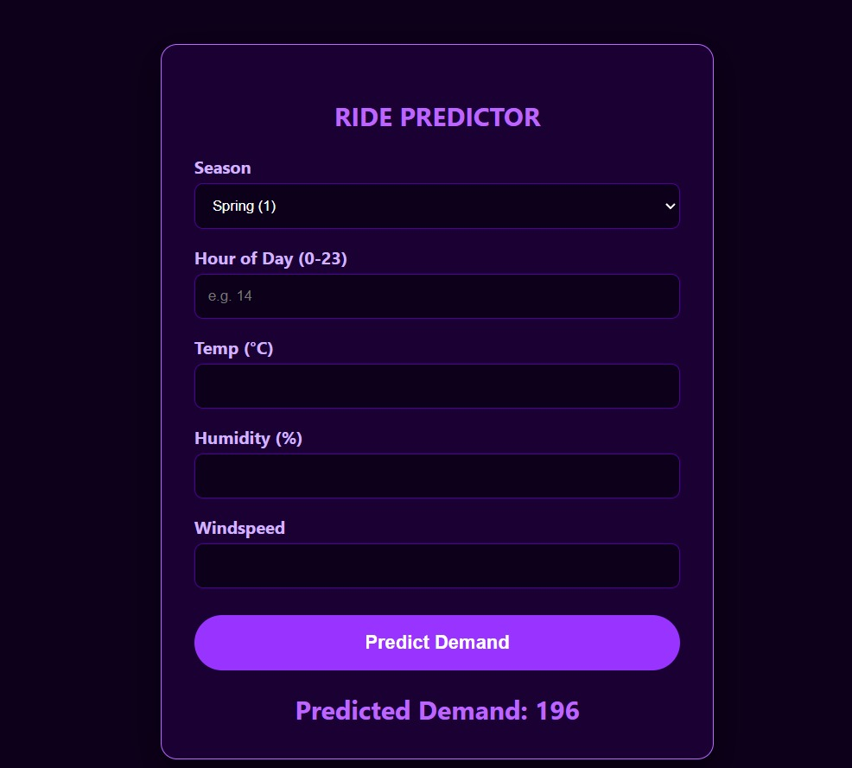

Conclusion

10. Conclusion
This project successfully developed a machine learning-based system to forecast Ola ride demand.
Key Outcomes:
- Identified important patterns in ride data
- Built an efficient predictive model
- Achieved reliable prediction accuracy
Impact:
- Helps optimize driver allocation
- Reduces waiting time
- Improves operational efficiency
The project demonstrates the effectiveness of machine learning in solving real-world transportation problems.

Future Scope & References

11. Future Scope
The project can be further enhanced in the following ways:
- Integration with real-time data sources
- Use of advanced models like LSTM or XGBoost
- Deployment on cloud platforms
- Incorporation of weather and traffic data
- Mobile or web-based user interface
These improvements can make the system more robust and industry-ready.

12. References
- Scikit-learn Documentation – https://scikit-learn.org
- Pandas Documentation – https://pandas.pydata.org
- Machine Learning Concepts – Research papers and online resources
- GeeksforGeeks – Ola Ride Prediction using ML
- Python Official Documentation – https://www.python.org

